FRAMES
Name: welcome.java
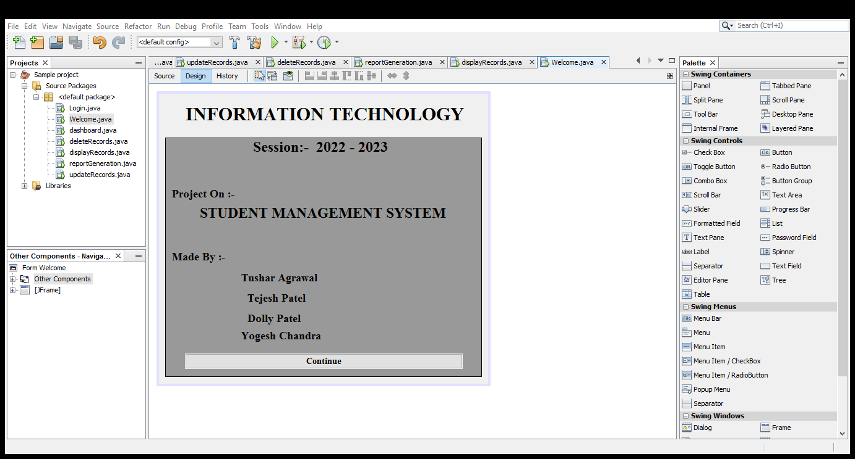

Name: login.java
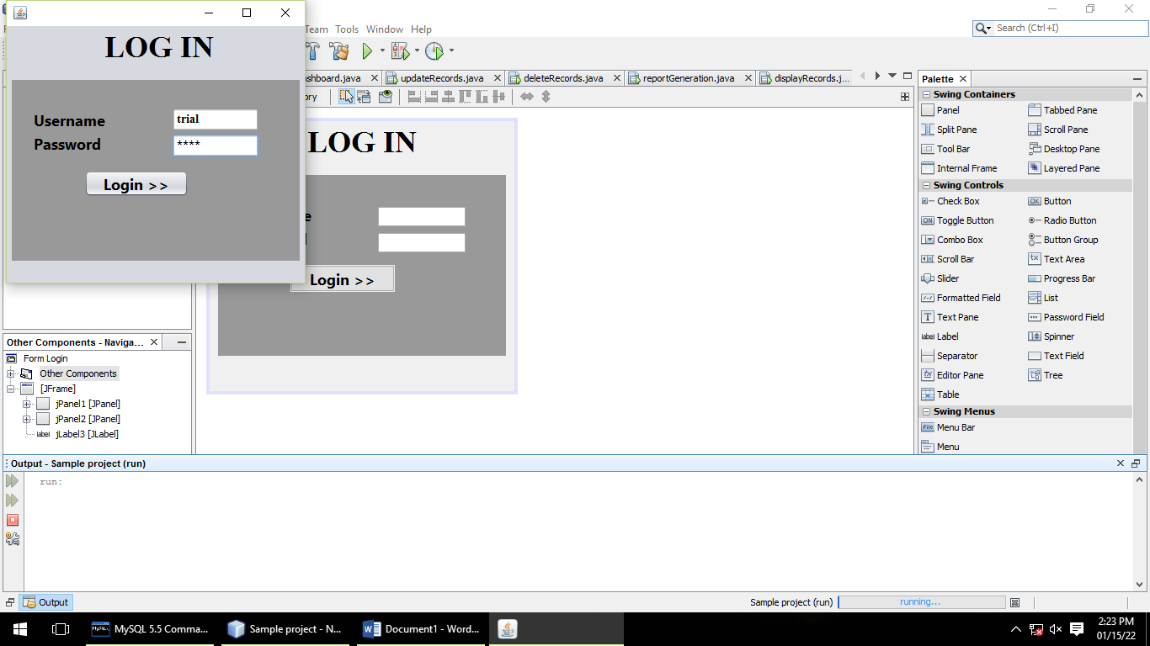

Name: dashboard.java
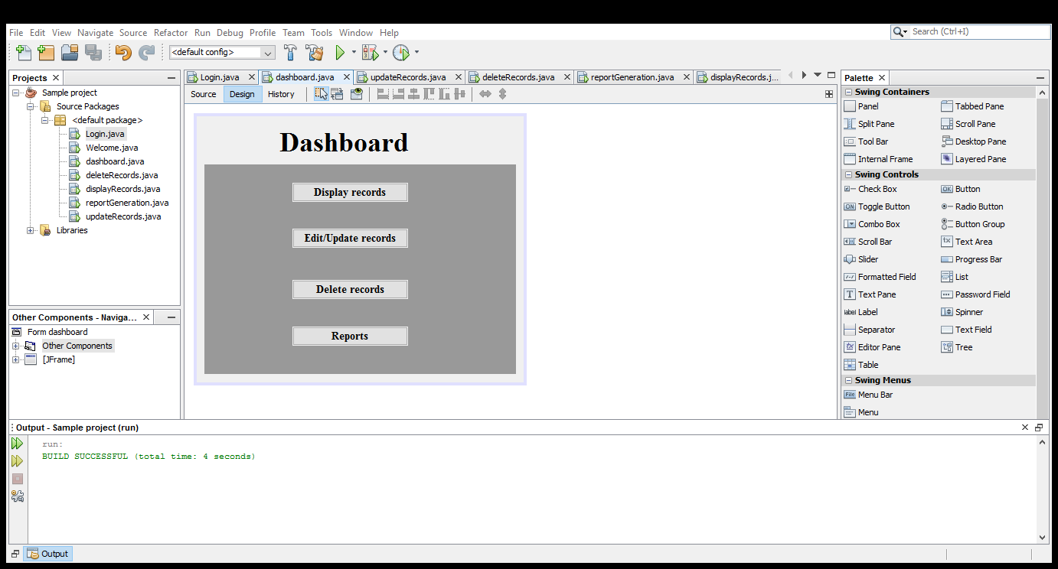

Name: displayRecords.java
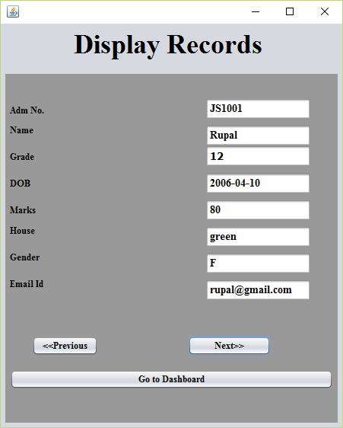

Name:deleteRecords.java
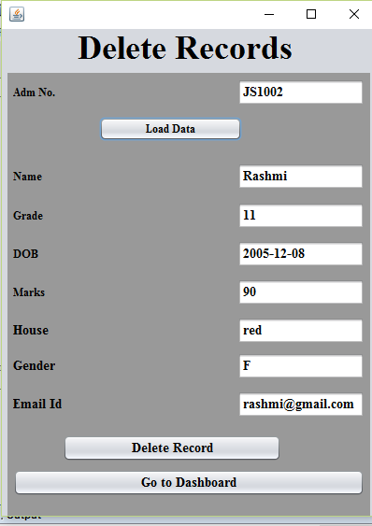

Name: reportGeneration.java
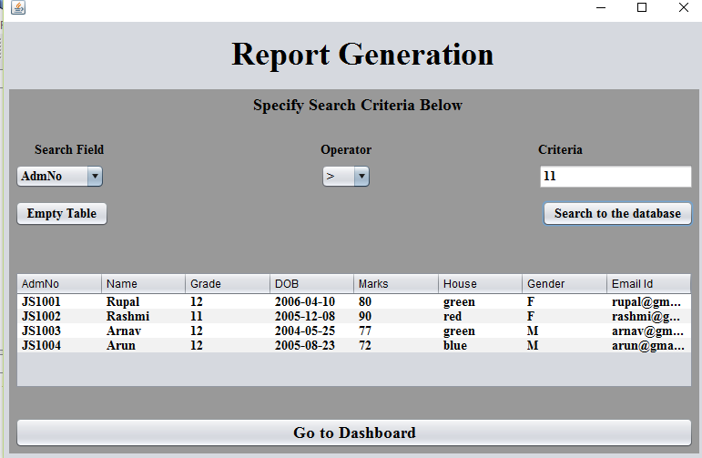

CODING

Welome.java
private void jButton1ActionPerformed(java.awt.event.ActionEvent evt) {
Login ln = new Login();
ln.setVisible(true);
}

login.java
import java.sql.*;
import javax.swing.JOptionPane;

public class Login extends javax.swing.JFrame {
Connection con = null;
Statement stmt = null;
ResultSet rs = null;

private void jButton1ActionPerformed(java.awt.event.ActionEvent evt) {
// TODO add your handling code here:
try{
Class.forName ("java.sql.Driver");
con = DriverManager.getConnection("jdbc:mysql://localhost/school", "root","opjs");

stmt = con.createStatement();
String s = JTF1.getText();
String pwd = new String (JPF1.getPassword());
String query = "Select * from users where username ='"+ s + "';";
rs = stmt.executeQuery(query);
if (rs.next()){
String t = rs.getString ("Password");
if (t.equals(pwd)){
new dashboard ().setVisible (true);
this.dispose();
}
else{
JOptionPane.showMessageDialog(null,"wrong username/password");
}
}
else {
JOptionPane.showMessageDialog (null,"wrong username");
}
stmt.close();
con.close();
}
catch (Exception e){
JOptionPane.showMessageDialog(null,e.getMessage());
}
}

dashboard.java
private void jButton2ActionPerformed(java.awt.event.ActionEvent evt) {
new updateRecords().setVisible(true);
this.dispose();
}

private void jButton1ActionPerformed(java.awt.event.ActionEvent evt) {
new displayRecords().setVisible(true);
this.dispose();
}
private void jButton3ActionPerformed(java.awt.event.ActionEvent evt) {
new deleteRecords().setVisible(true);
this.dispose();
}
private void jButton4ActionPerformed(java.awt.event.ActionEvent evt) {
new reportGeneration().setVisible(true);
this.dispose();
}

dispalyRecords.java
import java.sql.*;
import javax.swing.JOptionPane;

public class displayRecords extends javax.swing.JFrame {
Connection con=null;
Statement stmt=null;
ResultSet rs=null;

public displayRecords(){
initComponents();
try{
Class.forName("java.sql.Driver");
con=DriverManager.getConnection("jdbc:mysql://localhost/school","root","opjs");
Statement stmt=con.createStatement();
String query="select * from student;";
rs=stmt.executeQuery(query);
}
catch(Exception e){
JOptionPane.showMessageDialog(null, e.getMessage());
}
}

private void jButton2ActionPerformed(java.awt.event.ActionEvent evt) {
try{
if (rs.next()){
String s1 =rs.getString("admno");
String s2 =rs.getString("name");
String s3 =rs.getString("grade");
String s4 =rs.getString("DOB");
String s5 =rs.getString("Marks");
String s6 =rs.getString("house");
String s7 =rs.getString("gender");
String s8 =rs.getString("emailid");
JTF1.setText(s1);
JTF2.setText(s2);
JTF3.setText(s3);
JTF4.setText(s4);
JTF5.setText(s5);
JTF6.setText(s6);
JTF7.setText(s7);
JTF8.setText(s8);
}
else{
rs.previous();
JOptionPane.showMessageDialog(null,"Last Record!!!");
}
}
catch (Exception e){
JOptionPane.showMessageDialog(null,e.getMessage());
}
}

private void jButton1ActionPerformed(java.awt.event.ActionEvent evt) {
// TODO add your handling code here:
try{
if (rs.previous()){
String s1 =rs.getString("admno");
String s2 =rs.getString("name");
String s3 =rs.getString("grade");
String s4 =rs.getString("DOB");
String s5 =rs.getString("Marks");
String s6 =rs.getString("house");
String s7 =rs.getString("gender");
String s8 =rs.getString("emailid");
JTF1.setText(s1);
JTF2.setText(s2);
JTF3.setText(s3);
JTF4.setText(s4);
JTF5.setText(s5);
JTF6.setText(s6);
JTF7.setText(s7);
JTF8.setText(s8);
}
else{
rs.previous();
JOptionPane.showMessageDialog(null,"First Record!!!");
}
}
catch (Exception e){
JOptionPane.showMessageDialog(null,e.getMessage());
}
}

private void jButton3ActionPerformed(java.awt.event.ActionEvent evt) {
new dashboard().setVisible(true);
this.dispose();
}

updateRecord.java
import java.sql.*;
import javax.swing.JOptionPane;

public class updateRecords extends javax.swing.JFrame {
Connection con=null;
Statement stmt=null;
ResultSet rs=null;

private void jButton1ActionPerformed(java.awt.event.ActionEvent evt) {
try{
Class.forName("java.sql.Driver");
con=DriverManager.getConnection("jdbc:mysql://localhost/school","root","opjs");
stmt=con.createStatement();
String s=JTF1.getText();
String query="select * from student where admno='"+s+"';";
rs=stmt.executeQuery(query);
if (rs.next()){
String s2 =rs.getString("name");
String s3 =rs.getString("grade");
String s4 =rs.getString("DOB");
String s5 =rs.getString("Marks");
String s6 =rs.getString("house");
String s7 =rs.getString("gender");
String s8 =rs.getString("emailid");
JTF2.setText(s2);
JTF3.setText(s3);
JTF4.setText(s4);
JTF5.setText(s5);
JTF6.setText(s6);
JTF7.setText(s7);
JTF8.setText(s8);
jButton1.setEnabled(true);
}
else{
rs.previous();
JOptionPane.showMessageDialog(null,"Record not available!!!");
}
}
catch (Exception e){
JOptionPane.showMessageDialog(null,e.getMessage());
}
}

private void jButton2ActionPerformed(java.awt.event.ActionEvent evt) {
try{
Class.forName("java.sql.Driver");
con=DriverManager.getConnection("jdbc:mysql://localhost/school","root","opjs");
stmt=con.createStatement();
String s1 =JTF1.getText();
String s2 =JTF2.getText();
String s3 =JTF3.getText();
String s4 =JTF4.getText();
String s5 =JTF5.getText();
String s6 =JTF6.getText();
String s7 =JTF7.getText();
if(s7.equals(""))
s7= "NULL";
String s8 =JTF8.getText();
String query="Update student set name='"+s2+"',grade='"+s3+"',dob='"+s4+"',marks="+s5+",house='"+s6+"',gender='"+s7+"',emailid='"+s8+"' where admno='"+s1+"';";
stmt.executeUpdate(query);
JOptionPane.showMessageDialog(null,"Record saved successfully!!!!");
new dashboard().setVisible(true);
this.dispose();
}
catch (Exception e){
JOptionPane.showMessageDialog(null,e.getMessage());
}
}

private void jButton3ActionPerformed(java.awt.event.ActionEvent evt) {
new dashboard().setVisible(true);
this.dispose();
}

deleteRecord.java
import java.sql.*;
import javax.swing.JOptionPane;

public class deleteRecords extends javax.swing.JFrame {
Connection con=null;
Statement stmt=null;
ResultSet rs=null;

private void jButton2ActionPerformed(java.awt.event.ActionEvent evt) {
try{
Class.forName("java.sql.Driver");
con=DriverManager.getConnection("jdbc:mysql://localhost/school","root","opjs");
Statement stmt=con.createStatement();
String s=JTF1.getText();
String query="select * from student where admno='"+s+"';";
rs=stmt.executeQuery(query);
if (rs.next()){
String s2 =rs.getString("name");
String s3 =rs.getString("grade");
String s4 =rs.getString("DOB");
String s5 =rs.getString("Marks");
String s6 =rs.getString("house");
String s7 =rs.getString("gender");
String s8 =rs.getString("emailid");
JTF2.setText(s2);
JTF3.setText(s3);
JTF4.setText(s4);
JTF5.setText(s5);
JTF6.setText(s6);
JTF7.setText(s7);
JTF8.setText(s8);
jButton2.setEnabled(true);
}
else{
rs.previous();
JOptionPane.showMessageDialog(null,"Record not available!!!");
}
}
catch (Exception e){
JOptionPane.showMessageDialog(null,e.getMessage());
}
}

private void jToggleButton1ActionPerformed(java.awt.event.ActionEvent evt) {
try{
Class.forName("java.sql.Driver");
con=DriverManager.getConnection("jdbc:mysql://localhost/school","root","opjs");
stmt=con.createStatement();
String s1 =JTF1.getText();
String query="delete from student where admno='"+s1+"';";
stmt.executeUpdate(query);
JOptionPane.showMessageDialog(null,"Record deleted successfully!!!!");
new dashboard().setVisible(true);
this.dispose();
}
catch (Exception e){
JOptionPane.showMessageDialog(null,e.getMessage());
}
}

private void jButton3ActionPerformed(java.awt.event.ActionEvent evt) {
new dashboard().setVisible(true);
this.dispose();
reportGeneration.java
import java.sql.*;
import javax.swing.JOptionPane;
import javax.swing.table.DefaultTableModel;

public class reportGeneration extends javax.swing.JFrame {
Connection con=null;
Statement stmt=null;
ResultSet rs=null;

private void jButton1ActionPerformed(java.awt.event.ActionEvent evt) {
DefaultTableModel model=(DefaultTableModel)JTable2.getModel();
int rows=model.getRowCount();
if(rows>0){
for(int i=0; i<rows; i++){
model.removeRow(0);
}
}
}

private void jButton2ActionPerformed(java.awt.event.ActionEvent evt) {
jButton1.doClick();
DefaultTableModel model=(DefaultTableModel)JTable2.getModel();
try{
Class.forName("java.sql.Driver");
con=DriverManager.getConnection("jdbc:mysql://localhost/school","root","opjs");
Statement stmt=con.createStatement();
String s1=(String)JC1.getSelectedItem();
String s2=(String)JC2.getSelectedItem();
String s3=JTF1.getText();
String query="";
if(s1.equals("Grade") || s1.equals("Marks"))
query="select * from student where "+s1+s2+s3+";";
else
query="select * from student where "+s1+s2+"'"+s3+"';";
//System.out.println(""+query);
rs=stmt.executeQuery(query);
while(rs.next()){
model.addRow(new Object[]{
rs.getString("admno"),rs.getString("name"),rs.getString("grade"),
rs.getString("dob"),rs.getString("marks"),rs.getString("house"),
rs.getString("gender"),rs.getString("emailid")
});
}
}
catch(Exception e){
JOptionPane.showMessageDialog(null, e.getMessage());
}
}

private void jButton3ActionPerformed(java.awt.event.ActionEvent evt) {
new dashboard().setVisible(true);
this.dispose();
}

